Lecture 01
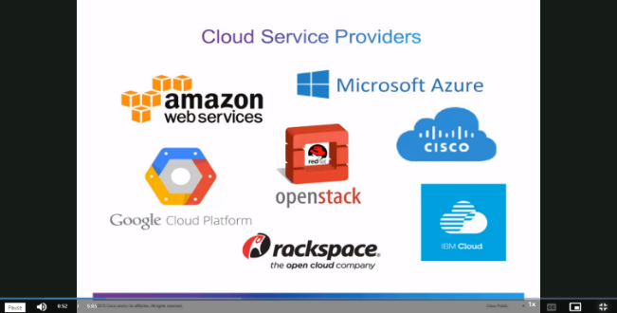
What is Cloud Computing?
  - On-demand availability of computer system resources, especially computing power and storage
  - automation of virtualization
  - Storing and accessing data and programs over the internet

The Deployment Models of the Cloud
Private Cloud:
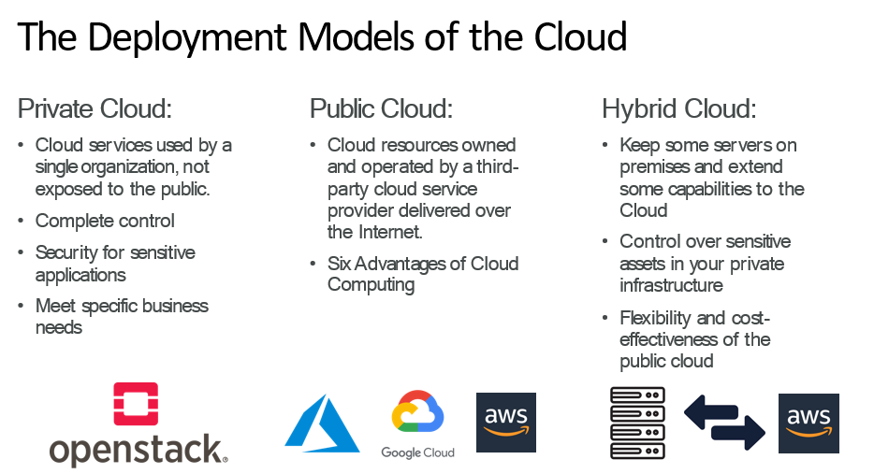
- Cloud services used by a single organization, not exposed to the public.
- Complete control
- Security for sensitive applications
- Meet specific business needs
Public Cloud:
- Cloud resources owned and operated by a third- party cloud service provider delivered over the Internet.
- Six Advantages of Cloud Computing
Hybrid Cloud:
- Keep some servers on premises and extend some capabilities to the Cloud
- Control over sensitive assets in your private infrastructure
- Flexibility and cost- effectiveness of the public cloud
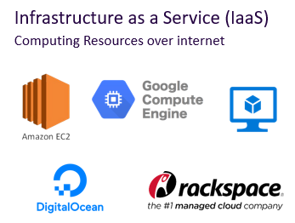
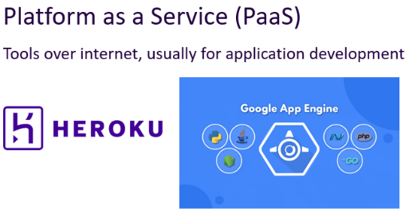
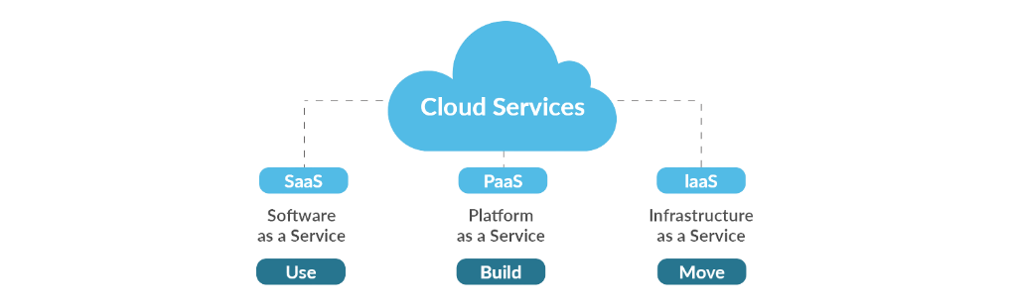

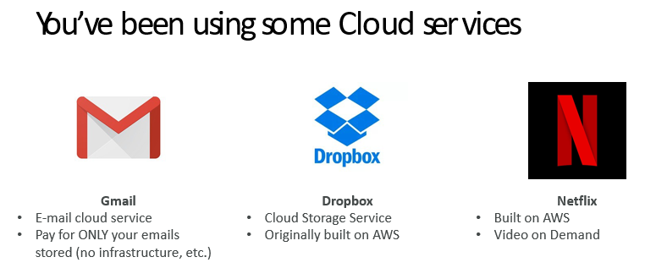
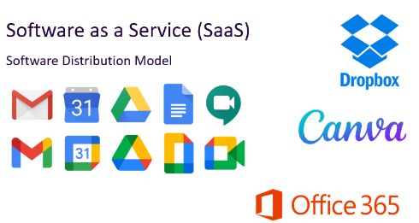

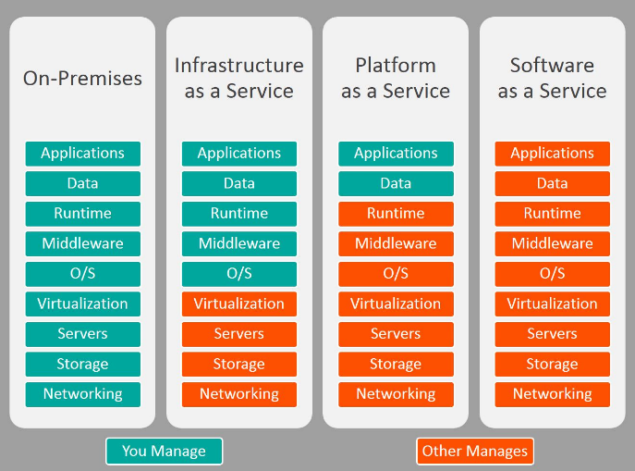
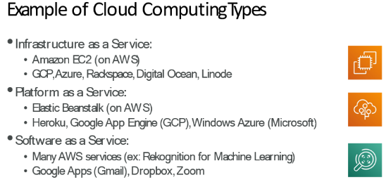

Lecture 7
What is a Server?
- Servers are computers that provide “services” to “clients”
- They are typically designed for reliability and to service a large number of requests
- Organizations typically require many physical servers to provide various services (Web, Email, Database, etc.)
- Server hardware is becoming more powerful and compact

Compact Servers
- Organizations would like to conserve the amount of floor space dedicated to their computer infrastructure
- For large-scale installations, compact servers are used. This helps with:
  - Floor Space
  - Manageability
  - Scalability
  - Power and Cooling

Blades and Blade Enclosures
- A blade server is a stripped down computer with a modular design
- A blade enclosure holds multiple blade servers and provides power, interfaces and cooling for the individual blade servers

What is a Data Center?
- A data center is a facility used to house computer systems and associated components, such as networking and
storage systems, cooling, uninterruptable power supply, air filters…
- A data center typically houses a large number of heterogeneous networked computer systems
- A data center can occupy one room of a building, one or more floors, or an
entire building

Data Center Components
- Air conditioning
  - Keep all components in the manufacturer’s recommended temperature range
- Redundant Power
  - UPS/Generators
  - Multiple power feeds
- Fire protection
- Physical security
  - CCTV/Access Control
- Monitoring Systems
- Connectivity
  - Multiple ISPs/Leased Lines

Lecture 12

Big Data refers to extremely large volumes of data—both structured and unstructured—that cannot be easily managed, processed, or analyzed using traditional databases and tools. It is often characterized by the 5 V's:
- Volume: Massive amounts of data
- Velocity: Speed of data generation and processing
- Variety: Different data types (text, images, videos, etc.)
- Veracity: Data accuracy and trustworthiness
- Value: Extracting meaningful insights from data

What Do We Do with Data?
We:
- Store it securely in databases or cloud storage
- Access it for analysis, decision-making, or application usage
- Process it to extract useful information, find patterns, and make predictions (e.g., through analytics or machine learning)

Requirements to Transform IT into a Service (ITaaS)
Transforming IT into a service involves turning infrastructure, software, or platforms into on-demand, scalable, and user-friendly services. Here are the key requirements:

Core Requirements
Requirement | Explanation
Connectivity | Reliable networking to move data efficiently across systems and locations.
Interactivity | Seamless user interfaces and APIs for smooth user-system interaction.
Reliability | High availability; failures must be minimal as they affect many users.
Performance | Services must perform well and be as fast or faster than traditional solutions.
Pay-as-you-Go | Users pay only for what they use—no upfront investment.
Ease of Programmability | Simple and flexible tools for developers to build and integrate services.
Manage Big Data | Capability to store, process, and analyze massive datasets.
Efficiency | Optimal use of resources (cost, power, space).
Scalability & Elasticity | Easily scale up/down based on demand—automatically or with minimal effort.

Example: Cloud-Based Customer Relationship Management (CRM) - Salesforce
How it meets the requirements:
- Connectivity: Accessible over the internet from any device.
- Interactivity: User-friendly dashboards, drag-and-drop UI, and robust APIs.
- Reliability: Uptime SLA of 99.9%, globally distributed data centers.
- Performance: Optimized infrastructure behind the scenes.
- Pay-as-you-Go: Subscription-based pricing.
- Ease of Programmability: Offers AppExchange and APIs for custom development.
- Manage Big Data: Can handle millions of customer records and interactions.
- Efficiency: Users don't worry about infrastructure; only pay for what they need.
- Scalability & Elasticity: Easily add users, features, or storage as the business grows.
Would you like a summarized infographic-style version of this table for easy use in a slide?

Lecture 14

Microsoft Azure Definition:
Microsoft Azure is a cloud computing platform and service offered by Microsoft that provides a wide range of on-demand cloud services, such as computing, storage, networking, databases, and AI, used to build, test, deploy, and manage applications through Microsoft-managed data centers.

Virtual Network (VNet) in Azure:
An Azure Virtual Network (VNet) is a logically isolated network in the Azure cloud where you can run your virtual machines (VMs), services, and applications securely. It is similar to a traditional on-premises network but with Azure resources.
- Supports subnets, routing, firewalls, VPN connections, and network security groups.
- Enables secure communication between:
  - Azure resources
  - On-premises infrastructure
  - The internet (if configured)

Three Examples of Azure Resources:
Resource | Purpose
Virtual Machine (VM) | Compute power to run applications, OS, and services
Azure Blob Storage | Store unstructured data like files, images, videos
Azure SQL Database | Managed relational database service

Resource Group in Azure:
A Resource Group in Azure is a container that holds related resources for an application or solution. It helps in organizing, managing, and monitoring resources as a single unit.
- Benefits:
  - Simplifies billing and access control
  - Allows bulk actions like deployment or deletion
  - Helps logically group by lifecycle or department

Azure subscriptions Case Study
An account can have multiple subscriptions, but it’s only required to have one. In a multi-subscription account, you can use the subscriptions to configure different billing models and apply different access-management policies. You can use Azure subscriptions to define boundaries around Azure products, services, and resources. There are two types of subscription boundaries that you can use:
• Billing boundary: This subscription type determines how an Azure account is billed
for using Azure. You can create multiple subscriptions for different types of billing
requirements. Azure generates separate billing reports and invoices for each
subscription so that you can organize and manage costs.
• Access control boundary: Azure applies access-management policies at the
subscription level, and you can create separate subscriptions to reflect different
organizational structures. An example is that within a business, you have different
departments to which you apply distinct Azure subscription policies. This billing
model allows you to manage and control access to the resources that users
provision with specific subscriptions.

Types of Azure Subscription Boundaries Identified in the Case Study
The case study highlights two types of Azure subscription boundaries:

1. Billing Boundary
- Purpose: Separates cost and billing for different departments, projects, or environments.
- Use in Case Study:
  - “You can create multiple subscriptions for different types of billing requirements.”
  - Each subscription gets separate billing reports and invoices, helping to organize and manage costs.
- Example: A company might create:
  - One subscription for development
  - Another for production
  - A third for testing, each with its own budget

2. Access Control Boundary
- Purpose: Enables setting different access-management policies per subscription.
- Use in Case Study:
  - “You can create separate subscriptions to reflect different organizational structures.”
  - Useful for isolating departments or teams by giving them separate control over their resources.
- Example:
  - HR, Finance, and IT departments each get their own subscription with role-based access tailored to their needs

On What Basis Should You Create Azure Subscriptions?
You should create Azure subscriptions based on logical separation of environments, access control, and cost management. Here are the main bases:

1. Environment-Based Separation
Create separate subscriptions for:
- Development
- Testing
- Staging
- Production
🔹 Why? To isolate resources, control access, and avoid accidental changes across environments.

2. Organizational Structure
Create subscriptions based on:
- Departments (e.g., HR, Finance, IT)
- Teams or Business Units
- Projects or Clients
🔹 Why? Each group can have tailored permissions and resource access, ensuring better governance.

3. Billing and Cost Management
Create subscriptions to:
- Track usage and cost by team, product, or project
- Separate chargebacks or budgets
🔹 Why? Azure bills at the subscription level, so this helps in monitoring and allocating expenses.

4. Compliance and Security
Create subscriptions to:
- Isolate sensitive data
- Meet regulatory or compliance needs (e.g., GDPR, HIPAA)
- Apply stricter security controls
🔹 Why? Security and access policies can be enforced at the subscription level.

Summary Table

Basis | Purpose | Example
Environment | Isolate dev/test/prod environments | Dev subscription, Prod subscription
Organizational Unit | Reflect teams/departments structure | Finance vs. IT subscription
Billing | Track and manage costs by workload or function | Subscription per project/client
Compliance/Security | Isolate resources/data to meet security or legal needs | Separate subscription for healthcare data

1) Requirements to Transform IT to Service (ITaaS - IT as a Service)
To transform IT into a service-oriented model, the following are essential:
- Standardization: Use standardized, repeatable IT services.
- Virtualization: Abstract computing resources to enable flexible provisioning.
- Automation: Automate provisioning, configuration, and management.
- Service Catalog: Provide a clear list of available IT services.
- Self-Service Portal: Allow users to request and manage services themselves.
- Monitoring & SLA Management: Track performance and ensure service-level agreements.
- Chargeback/Showback: Track usage and cost to promote accountability.
- Security & Compliance: Implement policies to protect data and meet regulations.

2) Why Cloud Computing?
Cloud computing is adopted because it:
- Reduces Costs: No need for upfront hardware investments.
- Scales Easily: Adjust resources based on demand.
- Offers Flexibility: Access services from anywhere.
- Increases Efficiency: Deploy applications faster.
- Supports Innovation: Test and develop applications without long setup.
- Provides Reliability: Built-in redundancy and data backup.
- Shifts to OPEX Model: Pay-as-you-go model improves budgeting.

3) Cloud Computing Services (Service Models)
- IaaS (Infrastructure as a Service):
Rent virtual machines, storage, and networks.
Example: AWS EC2, Google Compute Engine.
- PaaS (Platform as a Service):
Develop and deploy apps without managing infrastructure.
Example: Google App Engine, Microsoft Azure App Services.
- SaaS (Software as a Service):
Use ready-to-use applications over the internet.
Example: Google Workspace, Microsoft 365, Salesforce.

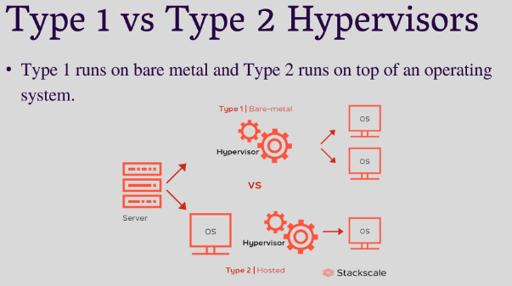
Virtualization
  - Creation of a virtual version of something
  - Simulates hardware functionality to create a virtual system

Type 1 Hypervisor: runs directly on the underlying computer's physical hardware, interacting directly with its CPU, memory, and physical storage
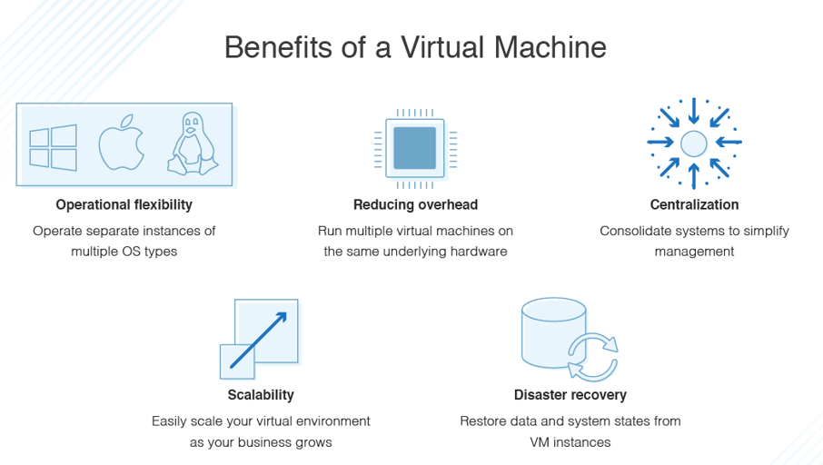
Type 2 Hypervisor: virtual machine (VM) manager that is installed as a software application on an existing operating system (OS)
Here's a shortened version of how to perform virtualization:

Steps to Perform Virtualization
- Choose Virtualization Type:
  - Server, Desktop, Storage, Network, or Application Virtualization.
- Select a Hypervisor:
  - Type 1 (Bare-metal) or Type 2 (Hosted).
- Install & Configure Hypervisor:
  - Install on hardware (Type 1) or as an app (Type 2).
  - Allocate resources for VMs.
- Create Virtual Machines (VMs):
  - Set up VMs and install operating systems.
- Manage & Monitor VMs:
  - Start, stop, clone, and monitor performance with tools like VMware vCenter or Hyper-V Manager.

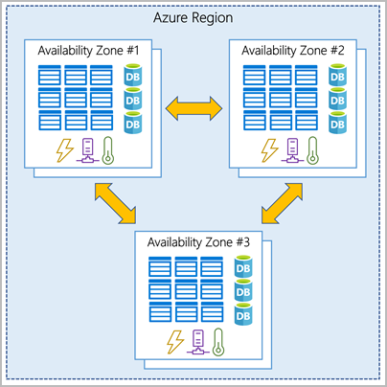
Availability Zones
Availability zones are physically separate datacenters within an Azure region. Each availability zone is made up of one or more datacenters equipped with independent power, cooling, and networking. An availability zone is set up to be an isolation boundary. If one zone goes down, the other continues working. Availability zones are connected through high-speed, private fiber-optic networks.

What Are Regions in Cloud Computing?
Regions are geographic areas where cloud providers (like Azure) host their data centers. Each region contains one or more availability zones for high availability.
Example Azure regions: East US, West Europe, Southeast Asia.

Microsoft Azure Services That Are Region-Independent:
These services operate globally and are not tied to a specific region:
- Azure Active Directory (AAD)
- Azure Traffic Manager
- Azure DNS
- Azure Content Delivery Network (CDN)
- Microsoft Entra ID (rebranding of AAD)
- Azure Front Door
- Azure DevOps
- Azure Resource Manager (control plane actions)

Advantages of Azure Region Pairs
- Disaster Recovery: One region acts as a backup for the other.
- Data Residency Compliance: Keeps data within the same geographic area.
- Automatic Replication: Services like Azure Storage automatically replicate data across the pair.
- Sequential Updates: Microsoft updates only one region at a time to reduce downtime risk.
- High Availability: Ensures business continuity even if one region fails.

Cost of Information Technology
Includes both CapEx (Capital Expenditure) and OpEx (Operational Expenditure):
- CapEx: Hardware, software licenses, servers, infrastructure setup
- OpEx: Maintenance, electricity, IT staff salaries, cloud subscription, support, upgrades
Cloud computing helps reduce CapEx and optimize OpEx with pay-as-you-go models.

Open Source Model – Definition
An Open Source Model is a software development and distribution model where:
- The source code is publicly available
- Anyone can use, modify, and distribute the software
- Encourages collaboration and transparency
- Examples: Linux, Kubernetes, Apache, MySQL
Here’s a concise breakdown of each question:

How to Offer Software as a Service (SaaS)?
- Develop the Software:
Build a web-based, multi-tenant application (e.g., using frameworks like Django, .NET, Node.js).
- Choose a Cloud Platform:
Host it on platforms like AWS, Azure, or GCP.
- Implement Subscription & Billing:
Add plans, payments, trials using Stripe, Razorpay, etc.
- Secure the Application:
Use HTTPS, authentication, data encryption, and backups.
- Deploy & Monitor:
Use CI/CD pipelines and tools like New Relic or Azure Monitor.
- Provide Support & SLA:
Offer customer service and guarantee uptime (e.g., 99.9%).

Benefits of Virtualization
- Resource Efficiency: Maximize hardware usage
- Cost Savings: Reduce hardware and maintenance costs
- Scalability: Easy to add/remove virtual machines
- Isolation: Separate environments on one physical server
- Disaster Recovery: Quick backups and recovery
- Testing & Development: Safe environment for experiments

Types of Virtualization
- Server Virtualization – Multiple virtual servers on one physical machine
- Desktop Virtualization – Access desktop environments remotely
- Storage Virtualization – Combine multiple storage systems into one
- Network Virtualization – Create virtual networks over physical networks
- Application Virtualization – Run apps without full installation
- Data Virtualization – Access and manipulate data without needing physical data location

RAID vs. Storage Virtualization
Feature | RAID (Redundant Array of Independent Disks) | Storage Virtualization
Purpose | Combines multiple disks for redundancy/performance | Pools storage from multiple devices
Level | Hardware or software-based disk management | Abstract layer above physical storage
Flexibility | Fixed configuration | Highly scalable and flexible
Data Location Awareness | Known/fixed | Data abstracted and may move dynamically
Examples | RAID 0, 1, 5, 10 | SAN, NAS, VMware vSAN, IBM Spectrum Virtualize

API – Definition
API (Application Programming Interface) is a set of rules and protocols that allows different software systems to communicate with each other.
Example: A weather app uses an API to get weather data from a weather server.

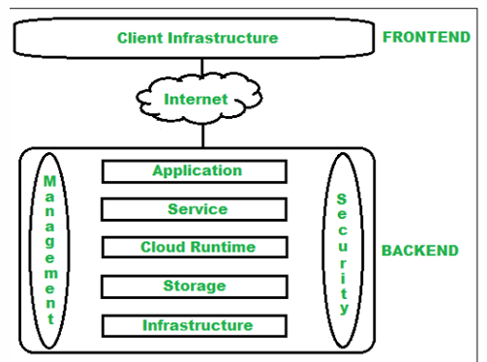
Cloud Computing Architecture

1. Frontend (Client Side)
- Interface the user interacts with (e.g., web browser, app)
- Client Infrastructure: Includes GUI and applications to access cloud services.

2. Backend (Cloud Side)
- Managed by the provider; delivers services and resources.
Includes:
- Application: Software/platform accessed by the user
- Service: SaaS, PaaS, IaaS management
- Runtime Cloud: Execution environment for VMs
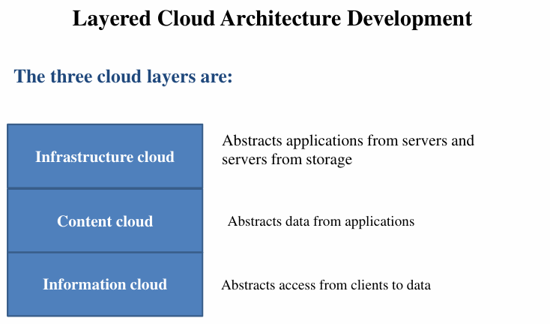
- Storage: Scalable and managed data storage
- Infrastructure: Servers, network, virtualization tools
- Management: Oversees all backend components
- Security: Ensures secure access to cloud resources
- Internet: Connects frontend to backend

Cloud Computing Design Challenges
- Ensuring Data Security and Privacy
- Managing Costs Effectively
- Handling Multi-Cloud Environments
- Addressing Performance-Related Issues
- Achieving Interoperability and Flexibility
- High Dependency on Network Connectivity
- Limited Knowledge and Expertise in Cloud Technologies

Cost Management
While most cloud service providers offer a “Pay-As-You-Go” pricing model that helps reduce upfront costs, enterprises can still face unexpectedly high expenses due to poor cost management. Common reasons include:
- Underutilized Resources: Servers and services that aren't fully optimized can lead to hidden costs.
- Performance Degradation: Poorly performing applications may require additional resources, increasing expenses.
- Usage Spikes: Sudden increases in demand or overages can cause significant cost surges.
- Unused Services: Forgetting to shut down inactive instances or services, especially during off-hours or weekends, leads to unnecessary charges.
Effective monitoring and resource management are essential to control these costs.

Infrastructural Constraints
- Transparency
- Scalability
- Intelligent Monitoring
- Security

